2015 US ALBACORE ASSOCIATION
MID-ATLANTIC CHAMPIONSHIPS and SHBC/MBC “OFF THE HOOK” Regatta

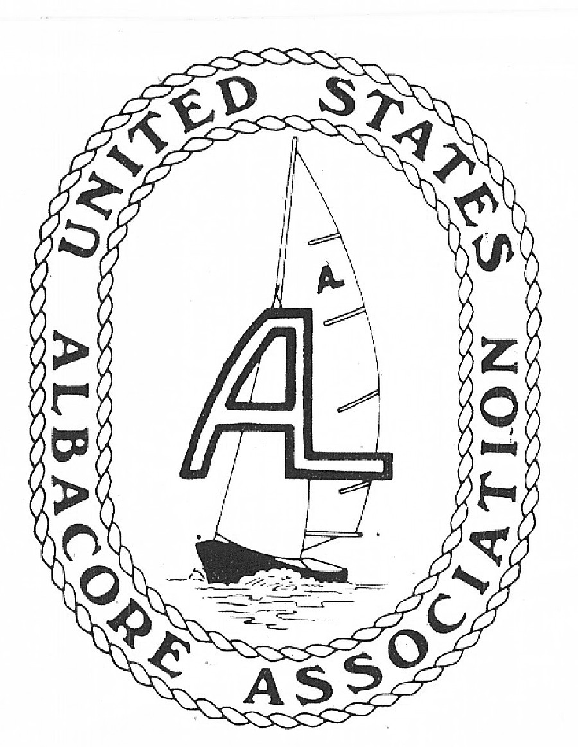July 18, 19, 2015

ORGANIZING AUTHORITY: UNITED STATES ALBACORE ASSOCIATION

CLUB/HOST ORGANIZATIONS: MOMMOUTH BOAT CLUB,
RED BANK, NJ
SANDY HOOK BAY CATAMARAN
CLUB, ATLANTIC HIGHLANDS, NJ

OFFICAL WEB SITES: www.albacore.org

NOTICE OF REGATTA

1. Rules: This regatta will be governed by The Racing Rules of Sailing for 2013-2015, the prescriptions of the US Sailing Association, and the rules of the United States Albacore Association, except as any of these are altered by this notice, and by the sailing instructions.

2. Eligibility and Entry: All boats must be helmed by a full or associate member of the United States Albacore Association or any other national Albacore Association. This championship will be a Category A event as it relates to advertising.

3. Number and Schedule of Races

Up to eight (8) races may be sailed. Several races may be sailed on any day at the discretion of the race committee. The warning signal for the first race on each day is scheduled as indicated below.

Sat. July 18 11:00 Skipper Meeting
12:00 Warning Gun for Race 1, other races to follow
Sun. July 19 9:30 Warning Gun for 1st race of the day, others to follow
Awards immediately following racing
No race will be started after 2:30 on Sunday July 19.

4. Social and Registration Schedule
Fri, July 17 7:00 – 9:00 Registration at Sandy Hook Bay Catamaran Club

Sat. July 18 9:00 – 10:00 Registration at Sandy Hook Bay Catamaran Club

Sat. July 19 6:00pm Party at Monmouth Boat Club

5. Advance Registration: Sailors may register in advance by completing the attached registration form and mailing it along with the entry fee to:
US Albacore Association
c/o Gene Spillane
18 Cooper Road
Pompton Plains, NJ 07444

6. Fees: The entry fee, in US dollars, is $80. Registration fee includes Saturday beach party for skipper/crew.

A $10 discount (from rates listed above) is available to current members of US Sailing, CYA, or RYA. Include a photocopy of your membership card with mailed applications or bring your card to registration to receive the reduced rate.

- Measurement: All boats must be accompanied by a valid measurement certificate with a current buoyancy endorsement. All boats must comply with the specifications for this event. No provision will be made for issuing new measurement certificates or endorsements at the regatta. All measurement must be complete in advance of the event.

- Safety Equipment: Each boat must carry safety equipment according to US Coast Guard Regulations (1 PFD per person, sound signal, paddle, bailer). In addition, each boat must carry on board during the regatta a line, suitable for towing, at least 30 feet in length and 1/4 inch thickness.

9. Sailing Instructions: Sailing instructions will be available at registration.

10. Scoring: The low point system of Appendix A of the racing rules will apply, subject to any modification in the sailing instruction. The completion of at least one race shall constitute a series. One drop race will be allowed if five or more races are sailed.

11. Crew Changes: crew changes during an event, may not be made unless permission is granted by the organizing committee in advance.

12. Awards: There will be awards for the first three places plus an award per USAA handicap.

- Launching: Beach launching at SHBCC is the preferred method of launch. A ramp is available at Atlantic Highlands Municipal Marina. (XXXX) three point lifting bridle is recommended.

- Accommodations:

Beach camping has been arranged with SHBCC, which includes showering and toilet facilities and electric hookups.

A partial list of nearby hotels is given below.

Extended Stay Middletown-Red Bank (USD 50-140)
329 Newman Springs Rd, Red Bank, NJ 07701; Tel: 1-732-450-8688, Fax: 1-732-450-8889

Courtyard by Marriott Red Bank (USD 90-190)
245 Half Mile Rd., Red Bank, NJ 07701; Tel: 1-732-530-5552, Fax: 1-732-530-5756

Camping: Cheesequake State Park; 1-732-566-2161, www.cheeseqakestatepark.com

Camping in not permitted on the MBC club grounds. Overnighting in the club house is not permitted. Some lodging with MBC members may be available. Contact Gene Spillane, (908)-397-5699 or at egspillane@earthlink.net

15. Further Information: visit http://www.albacore.org or contact Gene Spillane by phone at (908) 397-5699 or at EGSpillane@Earthlink.net

