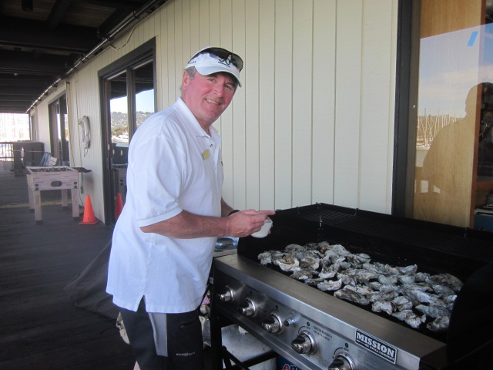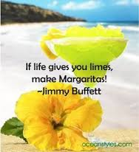
Oysters and Margueritas in Berkeley?
It has been confirmed – around 1730, on Friday, April 13 AND Saturday after the racing, there will Oysters!!! You need to be there.
46th Rollo Wheeler Memorial Regatta
APRIL 14 & 15, 2018
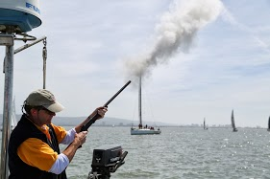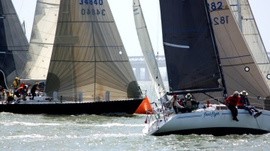
Register online at www.BerkeleyYC.org/race/46th-wheeler-regatta

